**上机实践4：类与对象**

**一、实验目的**

1. 掌握面向对象编程的特点及Java中类与对象的概念。
2. 掌握构造方法与对象的创建。
3. 掌握参数传值及方法重载。
4. 掌握this关键字、包、import语句。

**二、实验内容及步骤**

**实验1 机动车 掌握使用类封装对象的属性和功能。**

程序：

**package** cn.hbeu.example.eg1;

**public** **class** Vehicle {

**double** spped;

**int** power;

**void** speedUp(**int** s){

spped = s;

}

**void** speedDown(**int** d){

spped -=d;

}

**void** setPower(**int** p){

power = p;

}

**int** getPower(){

**return** power;

}

**double** getSpeed(){

**return** spped;

}

}

**package** cn.hbeu.example.eg1;

**public** **class** User {

/**

* **@param** args

*/

**public** **static** **void** main(String[] args) {

Vehicle car1, car2;

car1 = **new** Vehicle();

car2 = **new** Vehicle();

car1.setPower(128);

car2.setPower(76);

System.***out***.println("car1的功率是："+car1.getPower());

System.***out***.println("car2的功率是："+car2.getPower());

car1.speedUp(80);

car2.speedUp(80);

System.***out***.println("car1 目前的速度："+car1.getSpeed());

System.***out***.println("car2 目前的速度："+car2.getSpeed());

car1.speedDown(10);

car2.speedDown(20);

System.***out***.println("car1 目前的速度："+car1.getSpeed());

System.***out***.println("car2 目前的速度："+car2.getSpeed());

}

}

运行截图：

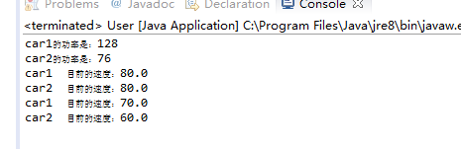

**实验2 家中的电视 掌握对象的组合以及参数传递。**

程序：

**package** cn.hbeu.example.eg2;

**public** **class** Family {

TV homeTV;

**void** buyTV(TV tv){

homeTV = tv;

}

**void** remoteControl(**int** m){

homeTV.setChannel(m);

}

**void** seeTV(){

homeTV.showProgram();

}

}

**package** cn.hbeu.example.eg2;

**public** **class** TV {

**int** channel;

**void** setChannel(**int** m) {

**if** (m >= 1) {

channel = m;

}

}

**int** getChannel() {

**return** channel;

}

**void** showProgram() {

**switch** (channel) {

**case** 1:

System.***out***.println("综合频道");

**break**;

**case** 2:

System.***out***.println("经济频道");

**break**;

**case** 3:

System.***out***.println("文艺频道");

**break**;

**case** 4:

System.***out***.println("国际频道");

**break**;

**case** 5:

System.***out***.println("体育频道");

**break**;

**default**:

System.***out***.println("不能收看"+channel+"频道");

**break**;

}

}

}

**package** cn.hbeu.example.eg2;

**public** **class** MainClass {

**public** **static** **void** main(String[] args) {

// **TODO** Auto-generated method stub

TV haierTV = **new** TV();

haierTV.setChannel(5);

System.***out***.println("haierTV的頻道是"+haierTV.getChannel());

Family zhangSanFamily = **new** Family();

zhangSanFamily.buyTV(haierTV);

System.***out***.println("zhangSanFamily 開始看電視節目");

zhangSanFamily.seeTV();

**int** m=2;

System.***out***.println("zhangSanFamily將電視更換到"+m+"頻道");

zhangSanFamily.remoteControl(m);

System.***out***.println("haierTV的頻道是"+haierTV.getChannel());

System.***out***.println("zhangSanFamily 在看電視節目");

zhangSanFamily.seeTV();

}

}

运行截图：

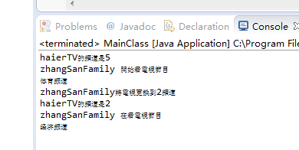

**实验3 共饮同井水 掌握类变量与实例变量，以及类方法与实例方法的区别。**

程序：

**package** cn.hbeu.example.eg3;

**public** **class** Land {

**public** **static** **void** main(String[] args) {

Village.*setWaterAmount*(200);

**int** leftWater = Village.*waterAmount*;

System.***out***.println("水井中有"+leftWater+"升水");

Village zhaoZhuang,maJiaHeZhi;

zhaoZhuang = **new** Village("趙莊");

maJiaHeZhi = **new** Village("馬家河子");

zhaoZhuang.setPeopleNumber(80);

maJiaHeZhi.setPeopleNumber(120);

zhaoZhuang.drinkWater(50);

leftWater = maJiaHeZhi.*lookWaterAmount*();

String name = maJiaHeZhi.name;

System.***out***.println(name+"發現水井中有"+leftWater+"升水");

maJiaHeZhi.drinkWater(100);

leftWater = zhaoZhuang.*lookWaterAmount*();

name = zhaoZhuang.name;

System.***out***.println(name+"發現水井中有"+leftWater+"升水");

**int** peopleNumber = zhaoZhuang.getPeopleNumber();

System.***out***.println("趙莊人口:"+peopleNumber);

peopleNumber = maJiaHeZhi.getPeopleNumber();

System.***out***.println("馬家河子人口:"+peopleNumber);

}

}

**package** cn.hbeu.example.eg3;

**public** **class** Village {

**static** **int** *waterAmount*;

**int** peopleNumber;

String name;

Village(String s){

name = s;

}

**static** **void** setWaterAmount(**int** m){

**if**(m>0){

*waterAmount* = m;

}

}

**void** drinkWater(**int** n){

**if**(*waterAmount* -n>=0){

*waterAmount* = *waterAmount* -n;

System.***out***.println(name+"喝了"+n+"升水");

}**else**{

*waterAmount* = 0;

}

}

**static** **int** lookWaterAmount(){

**return** *waterAmount*;

}

**void** setPeopleNumber(**int** n){

peopleNumber = n;

}

**int** getPeopleNumber(){

**return** peopleNumber;

}

}

运行截图：

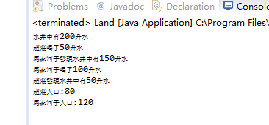

**实验4 求方程的根 掌握使用package和import语句**

程序：

**package** tom.jiafei;

**public** **class** SquareEquation {

**double** a,b,c;

**double** root1,root2;

**boolean** boo;

**public** SquareEquation(**double** a,**double** b,**double** c){

**this**.a=a;

**this**.b=b;

**this**.c=c;

**if**(a!=0){

boo=**true**;

}**else**{

boo=**false**;

}

}

**public** **void** getRoots(){

**if**(boo){

System.***out***.println("是一元二次方程");

**double** disk=b*b-4*a*c;

**if**(disk>=0){

root1=(-b+Math.*sqrt*(disk))/(2*a);

root2=(-b+Math.*sqrt*(disk))/(2*a);

System.***out***.printf("方程的根:%f,%f\n",root1,root2);

}**else**{

System.***out***.println("方程沒有實根");

}

}**else**{

System.***out***.println("不是一元二次方程");

}

}

**public** **void** setCoefficient(**double** a,**double** b,**double** c){

**this**.a=a;

**this**.b=b;

**this**.c=c;

**if**(a!=0){

boo=**true**;

}**else**{

boo=**false**;

}

}

}

**import** tom.jiafei.*;

**public** **class** SunRise {

**public** **static** **void** main(String[] args) {

// **TODO** Auto-generated method stub

SquareEquation equation = **new** SquareEquation(4,5,1);

equation.getRoots();

equation.setCoefficient(-3, 4, 5);

equation.getRoots();

}

}

运行截图：

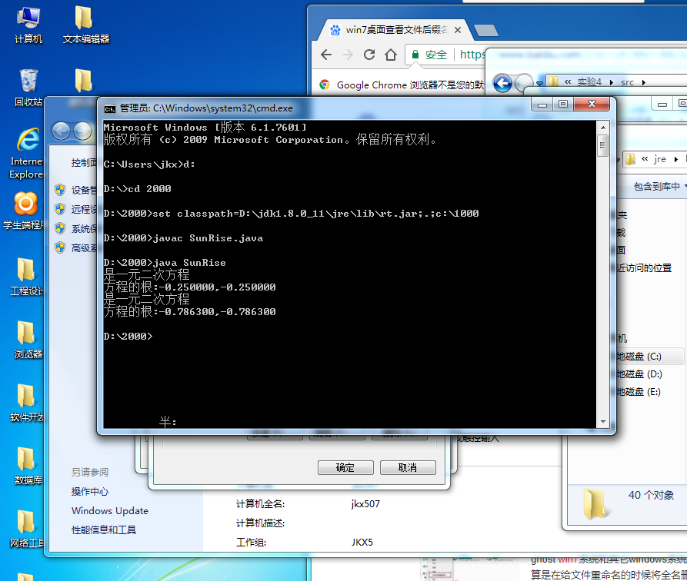

**三、实验小结**

掌握了面向对象编程的特点及Java中类与对象的概念。

掌握了构造方法与对象的创建。

掌握了参数传值及方法重载。

掌了握this关键字、包、import语句。